**CURRICULUM VITAE versus RESUME**

**CV and Resume** both are the most common terms in the recruitment industry. CV is a shorthand abbreviation of Curriculum Vitae. Curriculum Vitae is a Latin word that means “course of life”.  Both CVs and Resumes are referred to as a document that includes information about your achievements, experiences, and personal details. Both help you to get into the interview conversation. Yet, there is a minor difference between both terms. A resume is a one- to two-page document presenting key facts about your professional experience, educational background, and skills. A CV (Curriculum Vitae) is a longer document that details the whole course of your career. A resume is used for job search, a CV—for academic purposes. (<https://www.keka.com/glossary/cv-resume>)

**Curriculum Vitae (CV)** outlines the academic qualifications, researches, and other relevant details about a person, to represent him in front of employers. A **Resume** is to the point document, which underlines a person’s qualification for a specific job. When it comes to length, a CV is much larger than a resume.

**Comparison Chart**

|  |  |  |
| --- | --- | --- |
| **BASIS FOR COMPARISON** | **CURRICULUM VITAE (CV)** | **RESUME** |
| Meaning | A document containing information related to individual's past qualification, experience, skills, competencies and achievements is known as a CV or Curriculum Vitae. | A Resume is a document having details of an individual's education, work experience, competencies and previous job achievements. |
| Type of Document | Comprehensive | Concise |
| Etymology | Curriculum Vitae is a Latin expression which means course of life. | A French expression which means summary. |
| Length | 2 to 20 or more pages | 1 to 2 pages |
| References | Included | Not Included |
| Oriented towards | Academic qualification | Non-academic qualification |
| When to use | Applying for an academic position, advanced research, fellowship, etc. | Applying for the job, and internship or taking part in the job fair, etc. |
| Modification | No, it is same for all jobs | Yes, it can be modified according to job. |
| Stresses on | Expertise, i.e. what skills makes you an expert in a particular field. | Contribution, i.e. how your work made a difference, where you have worked. |
| Education | At the top of the CV | Mentioned after experience. |

(<https://keydifferences.com/difference-between-cv-and-resume.html>)

**What to Include on a CV**

1. Full name
2. [Contact information](https://novoresume.com/career-blog/contact-information-on-resume)
3. Professional title, [resume summary](https://novoresume.com/career-blog/resume-summary), or [resume objective](https://novoresume.com/career-blog/resume-objective-examples)
4. Research interests
5. Education
6. Publications (both academic papers and books)
7. Teaching or lecturing experience
8. Work experience
9. Conferences and courses
10. Skills
11. Certificates
12. Languages
13. Grants of fellowships
14. [References](https://novoresume.com/career-blog/how-to-list-references-on-resume)

**What to Include on a Resume**

1. Full name
2. Your [job title](https://novoresume.com/career-blog/job-titles-on-resume), or the name of the position you’re applying for
3. Contact information
4. Resume summary or objective
5. Work experience
6. Education
7. Relevant skills
8. Languages and proficiency
9. Relevant certifications and interests (if any)

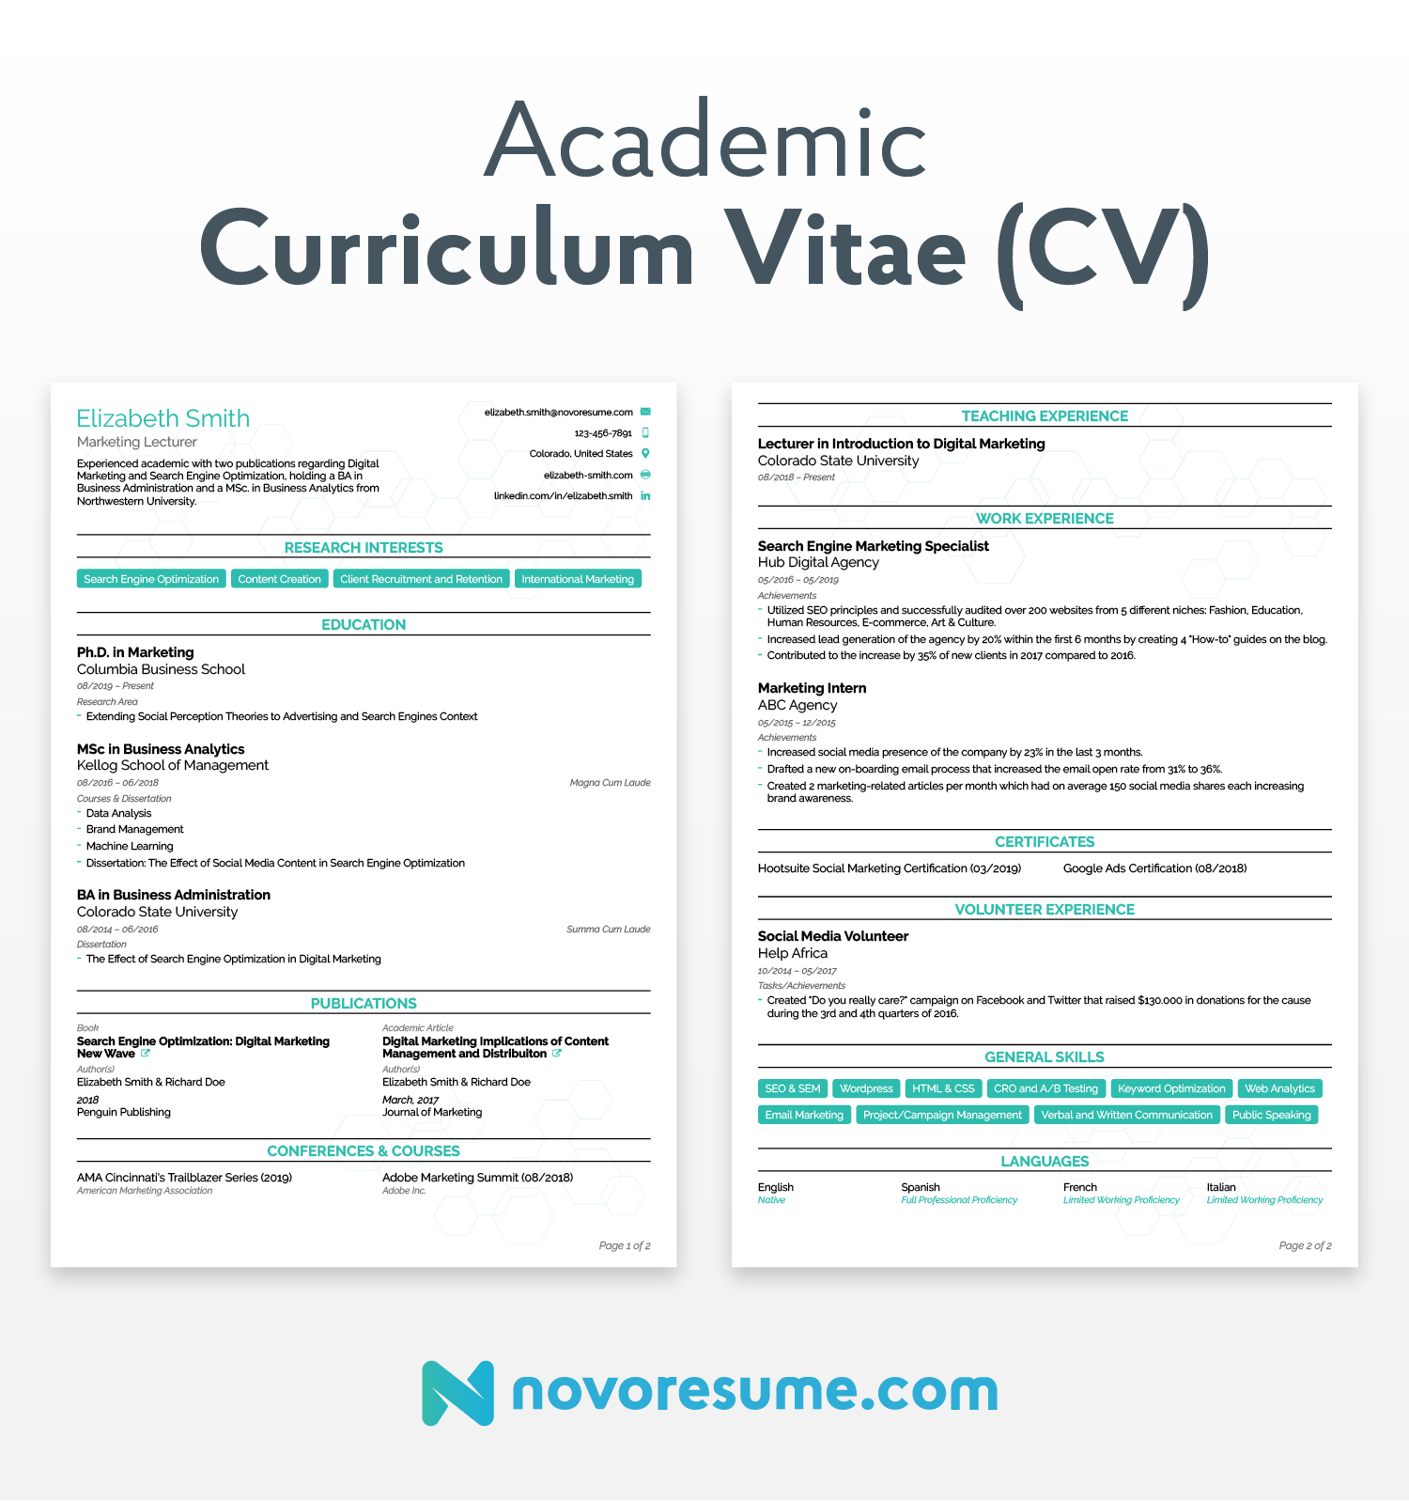

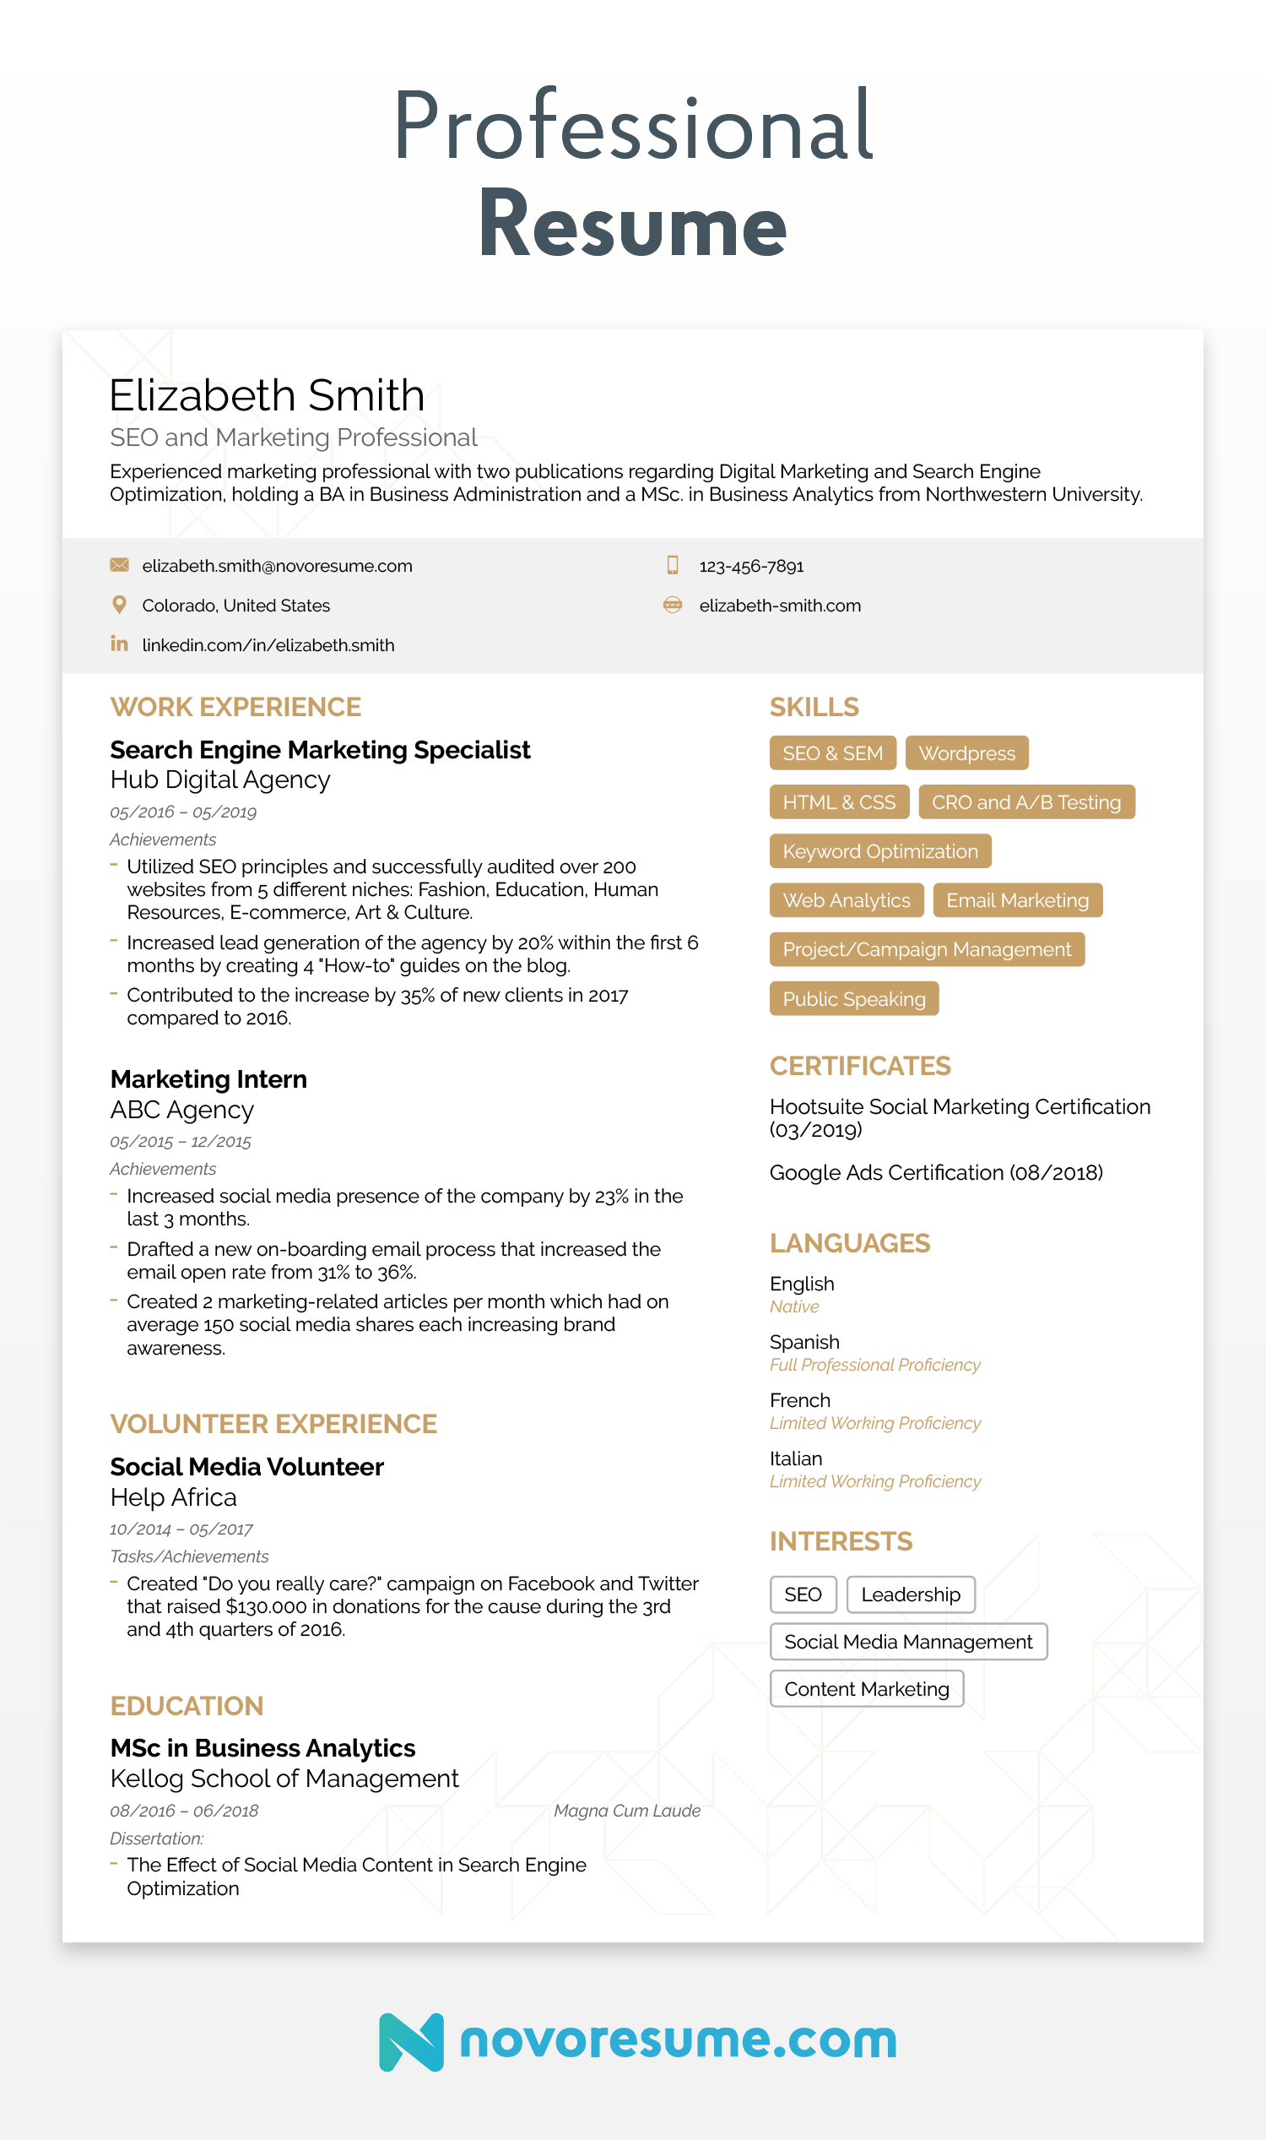

<https://novoresume.com/career-blog/cv-vs-resume-what-is-the-difference>